

44 Club

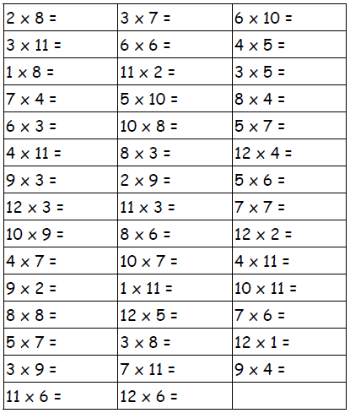Name:___________________ Date:________