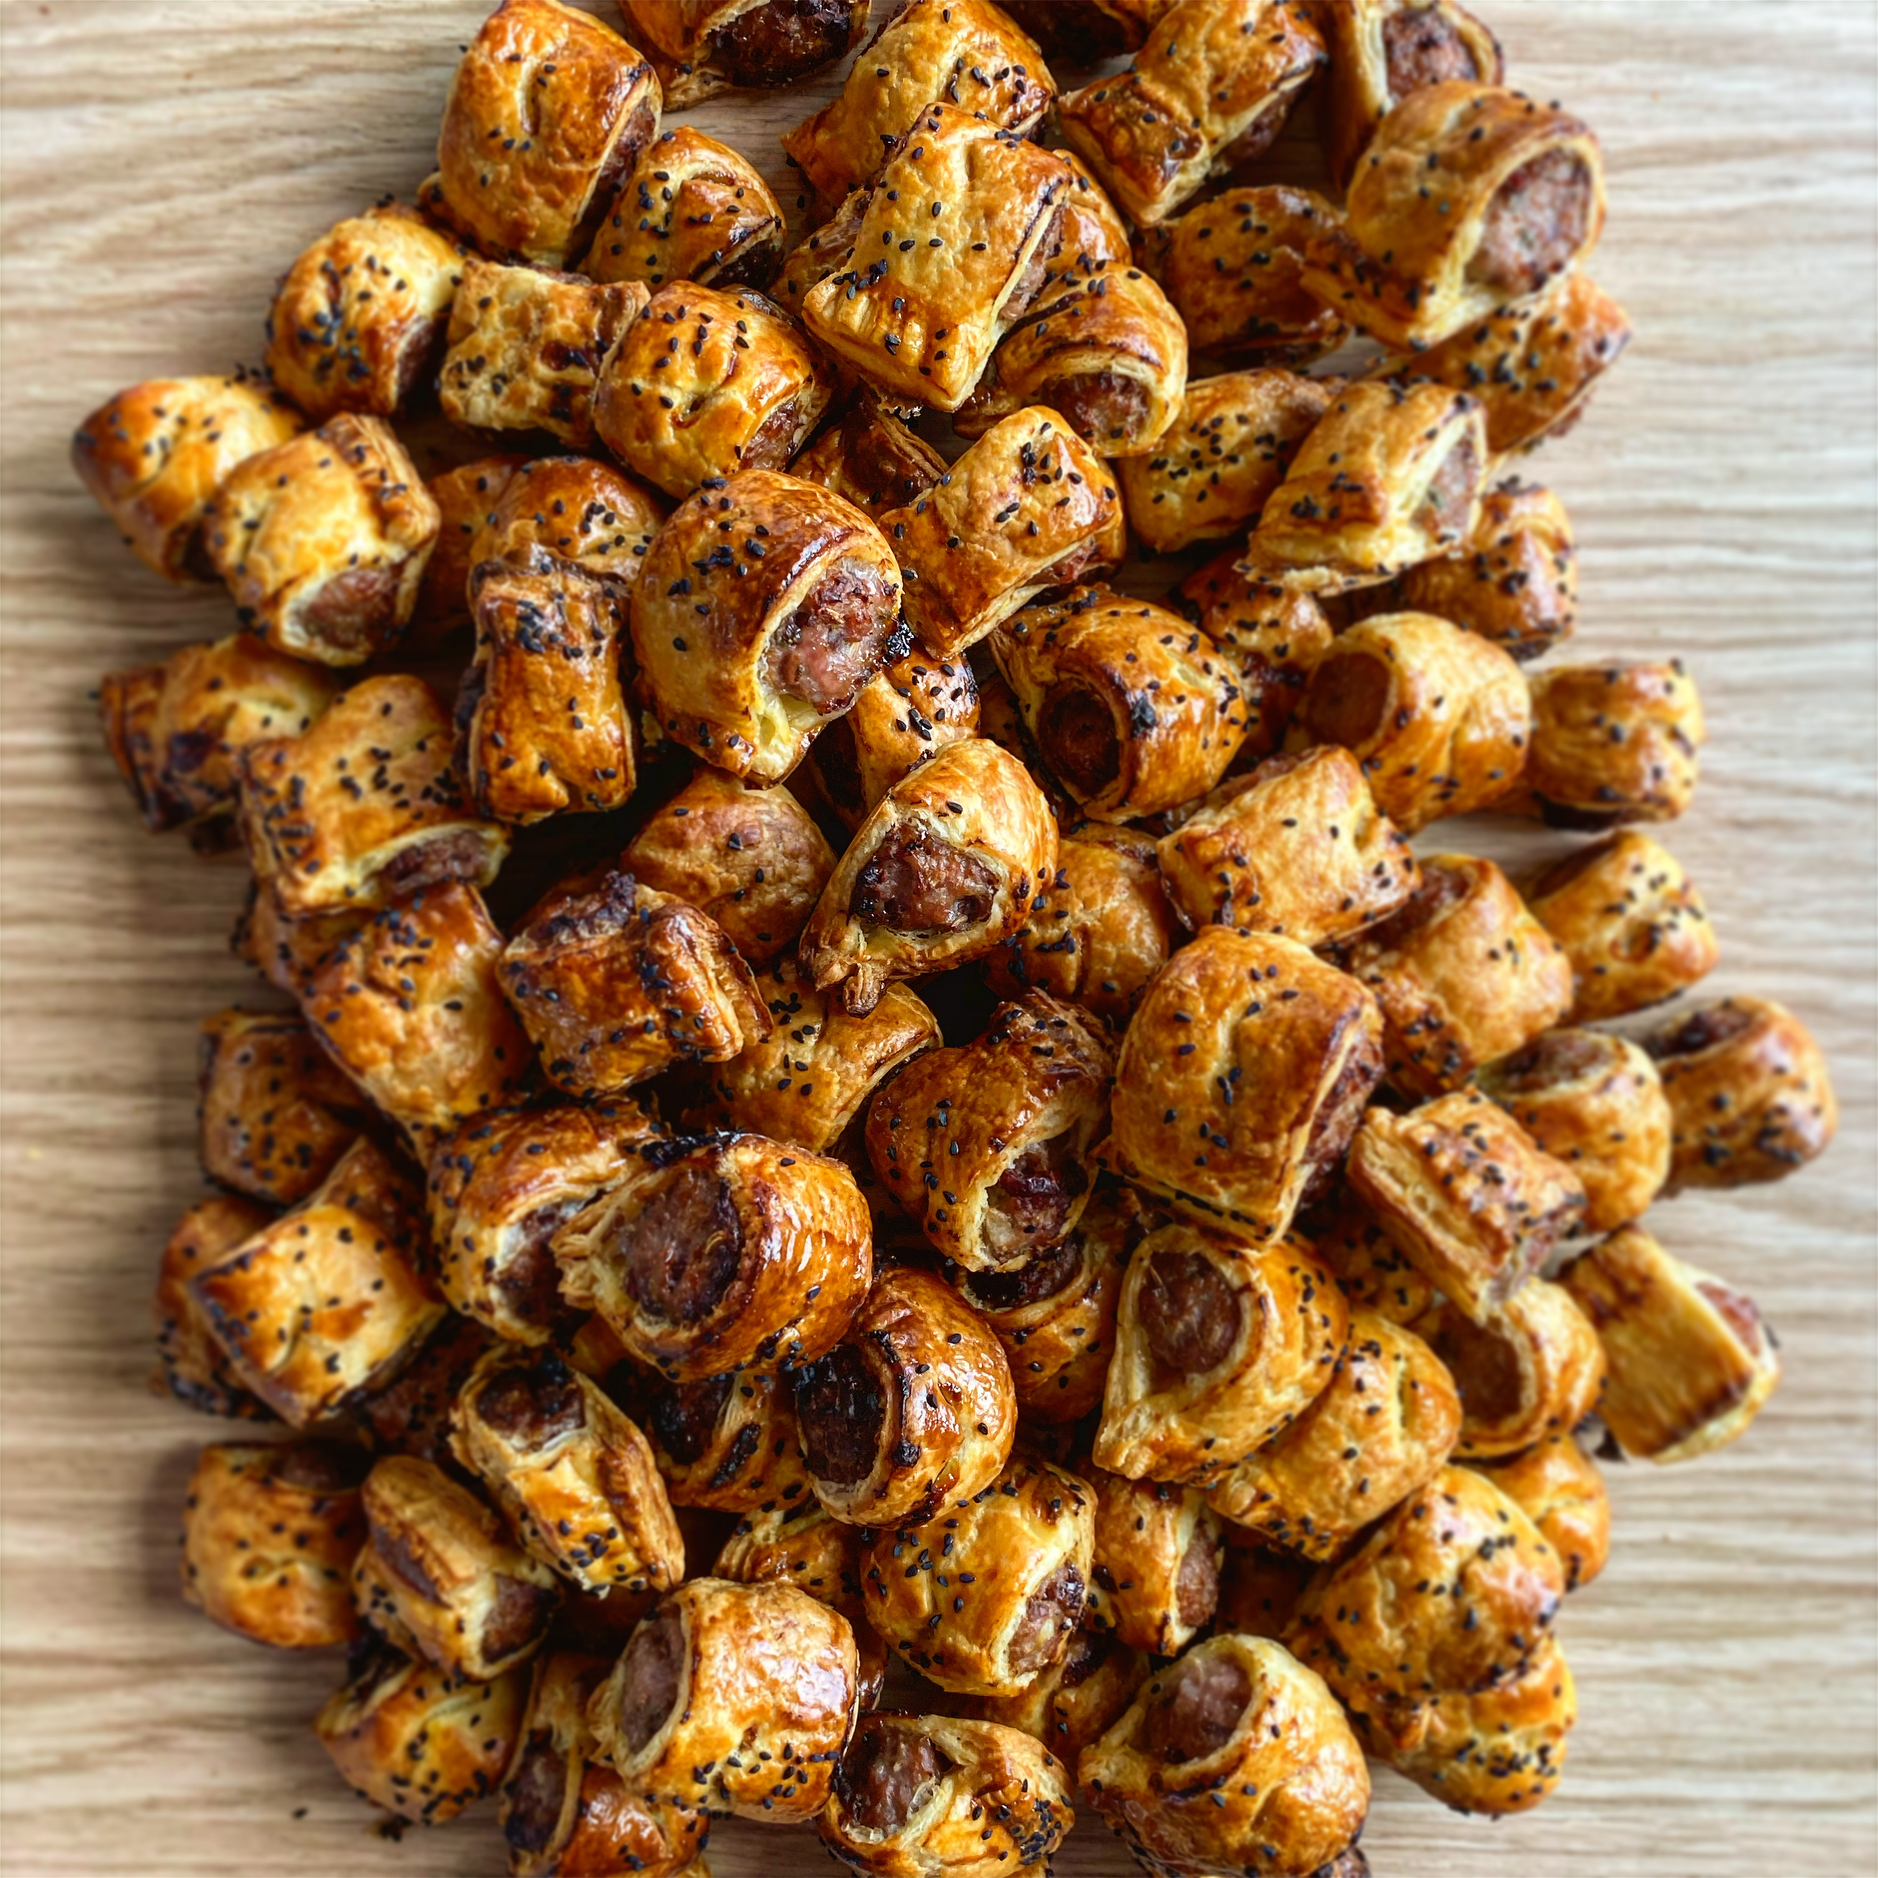

Makes 6 large sausage rolls
1 x 500g pack of puff pastry
1 tbsp olive oil
2 shallots
1 garlic clove
1 tbsp freshly chopped sage
500g sausage meat
50g dried apricots, roughly chopped
1 Cox apple, grated
1 tsp fennel seeds

Heat the olive oil in a medium sized pan over a low heat, gently fry the shallots and garlic for 10 minutes.

Stir through the sage and cook for a further 2 minutes. Set aside to cool..

Empty the sausage meat into a large mixing bowl and add the cooled shallots and garlic mix, apricots and grated apple. Season well and mix until combined.

Remove the chilled pastry from the fridge and roll, on a floured surface, to a large rectangle.
TRURO SCHOOL
COOKERY

Pork and apricot sausage rolls

Trim the sides to 23cmx30cm and then divide the pastry into two long lengths, each 35cmx15cm. Divide the sausage meat in two and shape into two long ‘sausages’.

Place in the centre of each pasty length and brush the edges of the pastry with a little beaten egg.

Fold the pastry over the sausage meat to cover, trim with a sharp knife and cut each length of pasty into 3. There should be 6 sausage rolls in total. Gently press the join of the pastry with a fork to secure.

Place the sausage rolls on a waxed paper on a baking sheet and brush with beaten egg. Place in the fridge for 15 minutes to chill completely.

Preheat the oven to 200°C

Brush with beaten egg and sprinkle over with fennel seeds and cook for 20–25 minutes, until puffed up and golden brown. Remove from the oven and allow to cool before serving.

