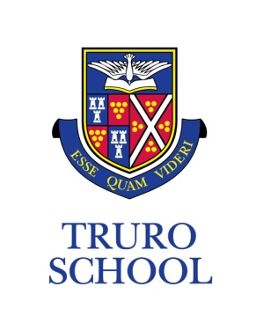
JOB DESCRIPTION

JOB TITLE: Cookery Assistant (Prep)
REPORTING TO: Cookery Teacher/Head of Prep
ROLE OVERVIEW
We are looking for an enthusiastic and passionate assistant who will share their love of baking and cooking with our pupils and assist the Cookery Teacher during lessons.

KEY RESPONSIBILITIES
- Assist the teacher (of cooking) prior to a cookery session by getting out the appropriate equipment, utensils and ingredients as instructed by the teacher; (15 mins before lesson starts).

- Assist the teacher during the cookery session by assisting and guiding the pupils where necessary;

- Remain vigilant during cookery sessions for any potential hazards or dangers the pupils may encounter and assisting the teacher and pupils in avoiding these;

- Encourage through interactions with the pupils a safe, sensible and hygienic approach to cooking;

- Assist the teacher with clearing up and washing-up after a cookery session and ensuring that the classroom is returned to a safe and fit condition for the next lesson to commence (15 mins after lesson).

PERSON SPECIFICATION
Essential:
- Educated to a minimum standard of GCSE (grade A* - C or equivalent)
- Good communication skills
- Sensitive to the Methodist ethos of the School and an understanding of independent school philosophy
- Enthusiasm for baking and cooking

Desirable:

- Previous experience of working with children
- Food hygiene qualification
- First Aid qualification

ADDITIONAL

- Truro School is committed to safeguarding and promoting the welfare of children and young people and expects all staff and volunteers to share this commitment and behave accordingly. This role will involve daily contact with students.
- This job description sets out current duties of the post that may vary from time to time without changing the general character of the post or the level of responsibility entailed.

Date reviewed: Sept 2020
Reviewed by: Head of Prep

