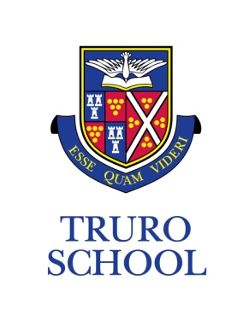

JOB DESCRIPTION

JOB TITLE: Teacher of Physical Education & Games

GRADE: Truro School Teachers’ Pay Scale

REPORTING TO: Director of Sport / Head of Academic PE
______________________________________________________________________________

KEY FUNCTIONS

- be an enthusiastic and innovative teacher who can motivate and inspire students using a wide range of teaching strategies
- teach co-educationally across the age groups, encouraging and developing the sports skills of the students in their classes, setting high expectations
- plan for and deliver excellent teaching and learning
- be aware of and implement department schemes of work, contribute to these working documents to keep up with current pedagogies
- actively contribute to the co-curricular life of the School. This may include before School, after School, weekends and occasionally during the holidays
- take the lead in a sport driving it forward within the Sports Strategy for the School
- have an excellent knowledge of many sports to inspire our students
- have a desire for change and show innovation and vision
- adhere to the School’s and department’s code of conduct on Health and Safety
- be a team player who is adaptable, motivated and has leadership qualities.

The general responsibilities of all teachers at Truro School are to:

- undertake form tutor responsibilities
- actively participate in the co-curricular life of the School
- plan and prepare for the short, medium and long term
- teach according to the educational needs of the students
- provide a stimulating environment for learning to take place
- assess, record and report on the development, progress, behaviour and attainment of students and maintain effective records
- participate in all necessary arrangements and procedures for assessment
- maintain good order and discipline among students
- undertake supervision duties as required by the Senior Leadership Team
- provide pastoral care and guidance to students as appropriate
- participate in staff meetings and discussions as required by the Senior Leadership Team
- undertake INSET as part of the School’s development plan
- participate in the School’s monitoring and evaluation annual cycle
- adhere to the School’s policies and procedures regarding reporting to parents
- act at all times as a professional member of staff

PERSON SPECIFICATION

Essential Criteria

- excellent classroom practitioner who can lead by example
- recent and appropriate experience of working with Key Stage 3 to 5 students
- an appropriate teaching qualification/experience
- inspired by the School’s mission and aim, and a commitment to vigorously promote and model the behaviours and values expected of others
- collaborative working practices developed and demonstrable
- excellent knowledge of many sports to inspire our students
- ability to manage change and work under the pressure of changing circumstances
- excellent organisation skills with the proven ability to implement and see things through to completion
- excellent communication skills, both written and verbal
- a clear enhanced DBS disclosure
- an empathy and understanding of expectations within Independent Schools education
- an understanding of the School’s Methodist traditions and ethos
- the ability to use ICT to a high standard within the classroom context

ADDITIONAL

- Truro School is committed to safeguarding and promoting the welfare of children and young people and expects all staff and volunteers to share this commitment and behave accordingly.
- This job description sets out current duties of the post that may vary from time to time without changing the general character of the post or the level of responsibility entailed.

Date prepared: April 2020

Prepared by: Director of Sport/Director of Co-Curricular

