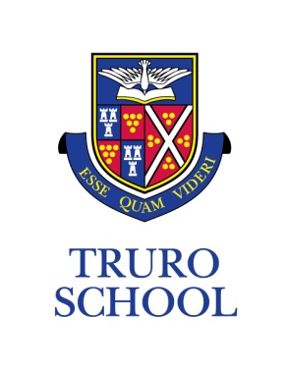
JOB DESCRIPTION

JOB TITLE: Cookery School Assistant
GRADE: AS13 – AS17
REPORTING TO: Assistant Head of Cookery School

ROLE OVERVIEW
Truro School Cookery School is a busy and growing cookery school, café and Sixth Form café based at Truro School. The Chef de Partie will create and produce a range of new and exciting menus and recipes for a daily lunch service of up to 150 covers.

KEY RESPONSIBILITIES
- Design, cost, prepare and serve an exciting nutritious lunch menu of around 150 covers
- Mentor a Chef Apprentice who will support the preparation and delivery of the lunch menu
- Ensure excellent standards of food hygiene and health and safety are maintained at all times
- Ensure the kitchen and all associated areas are cleaned and maintained to excellent standards in accordance with all relevant legislation
- Ensure all equipment is maintained in good, clean working order at all times
- Responsible for the ordering, stock control and use of all ingredients within tight budgets
- Build good working relationships with suppliers to ensure a reliable supply of cost effective ingredients
- Support and train other team members, as required
- By arrangement, to support external events at weekends and evenings as required on a zero hours basis

PERSON SPECIFICATION
Essential:
- Educated to a minimum standard of GCSE (grade A* - C or equivalent)
- Proven track record working within a busy commercial kitchen environment
- Ability to design, plan and cost creative current menus
- Excellent working knowledge of a wide range of dietary requirements
- Experience of stock control and ordering from a range of suppliers
- Proven track record of working within and maintaining tight budgets
- Ability to work positively and effectively under pressure as part of a team and to manage a busy workload including evenings and weekends as required
- Self motivated and reliable with a disciplined work ethic
- Willingness to learn and develop new ideas and styles of cooking
- Approachable with excellent interpersonal skills, both written and verbal
- Ability to provide excellent customer service to all customers.
- Ability to develop good working relationships with colleagues and all members of the wider school community
- Sensitive to the Methodist traditions and ethos of the School

Desirable:

- Level 3 qualification in a relevant field
- Up to date qualifications in relevant fields e.g. Food hygiene, first aid
- Interest and knowledge of current food trends, recipes and ingredients
- Ability to use leftover ingredients creatively
- Experience of costing recipes and dishes
- Computer literate with experience of MS Office packages including outlook, excel and word

ADDITIONAL

- Truro School is committed to safeguarding and promoting the welfare of children and young people and expects all staff and volunteers to share this commitment and behave accordingly. This role will involve daily contact with students.
- This job description sets out current duties of the post that may vary from time to time without changing the general character of the post or the level of responsibility entailed.

Date reviewed: December 2019
Reviewed by: Head of Cookery School

