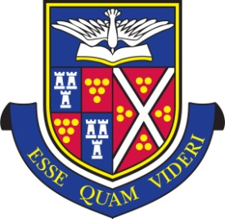
TRURO SCHOOL

Art Scholarship Entry Form

Please complete this form and send it with copies of any relevant documents, to: Jayne Grigg, Director of Admissions, Truro School, Trennick Lane, Truro TR1 1TH or email to: admissions@truroschool.com

Please make sure you have also completed a registration form for your son/daughter

Pupil’s Name .....................................................................................………………………………………

Date of Birth .......................................... 11+ 13+ 16+ Application

Present School ............................................................................................................

You are required to prepare two pieces of work to submit with the application form:

- A piece of work entitled ‘This is Me’. This can be produced in any type of media, 2D or 3D. Please ensure that your piece is clearly labelled with the applicant’s name, and whether the application is for 11+, 13+ or 16+.

- A paragraph on a specific painting or sculpture explaining why you chose it and what you have learned from looking at it. You should choose a piece by an artist that has inspired you and make sure that you make insightful comments about the work you have chosen. Please handwrite or type this piece in the text box on the second page.

Please return this form by

16+ Friday 8 November 2019
11+ and 13+ Friday 13 December 2019

I understand and accept the expectations of scholars outlined in the scholarship information

Parent’s Signature ........................................................................................ Date .........................

Name of Artist....................................................................................................................................

Name of Piece of Work ....................................................................................................................

Medium………………………………………………………………………………………………………

